Practical No. 7

MySQL Backup and Restore using Python

**Q.1]** Implement back and restore for MySQL using Python.

**Database:**

CREATE DATABASE IF NOT EXISTS studentrepo;

USE studentrepo;

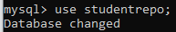

CREATE TABLE IF NOT EXISTS students (

    id INT AUTO_INCREMENT PRIMARY KEY,

    name VARCHAR(100),

    age INT,

    class VARCHAR(50),

    city VARCHAR(100),

    phoneno VARCHAR(20),

    email VARCHAR(100)

);

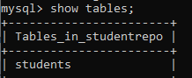

INSERT INTO students (name, age, class, city, phoneno, email) VALUES

('John Doe', 20, 'Physics', 'New York', '555-1234', 'johndoe@example.com'),

('Jane Smith', 22, 'Computer Science', 'Los Angeles', '555-5678', 'janesmith@example.com'),

('Sam Brown', 19, 'Mathematics', 'Chicago', '555-8765', 'sambrown@example.com'),

('Lucy Green', 21, 'Biology', 'Houston', '555-4321', 'lucygreen@example.com'),

('Tom White', 23, 'Chemistry', 'San Francisco', '555-3456', 'tomwhite@example.com');

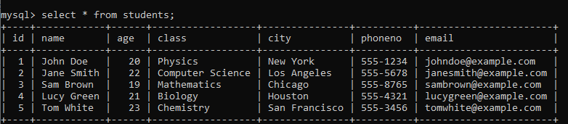

**Code:**

import os

MY_SQL_PATH = "C:/Program Files (x86)/MySQL/MySQL Server 5.5/bin"

def backup (user, password, database_name, backup_path, backup_file_name):

    command = f"mysqldump -u{user} -p{password} {database_name} > {backup_path}/{backup_file_name}"

    os.chdir(MY_SQL_PATH)

    os.system(command)

    print("Database Backup Successful")

def recovery(user, password, database_name, backup_path, backup_file_name):

    command = f"mysql -u{user} -p{password} {database_name} < {backup_path}/{backup_file_name}"

    os.chdir(MY_SQL_PATH)

    os.system(command)

    print("Database Recovery successful")

print("Select Operation: \n1. Backup\n2. Recovery")

operation=int(input("Enter operation: "))

if operation==1:

    backup(

    input("\nEnter username: "),

    input("Enter password: "),

    input("Enter Database Name: "),

    input("Enter Backup Path: "),

    input("Enter Backup Name: "),)

elif operation==2:

    recovery(input("\nEnter username: "),

            input("Enter password: "),

            input("Enter Database Name: "),

            input("Enter Backup Path: "),

            input("Enter Backup Name: "),)

else:

    print("Invalid Operation")

#C:/Users/student/Documents/MYSQLBackup

**Output:**

**Backup the database before dropping**

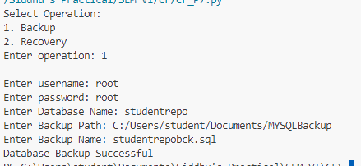

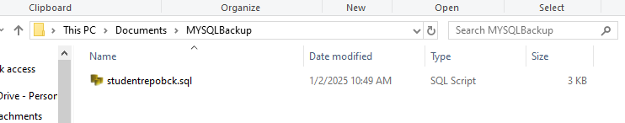

**Dropping the database**

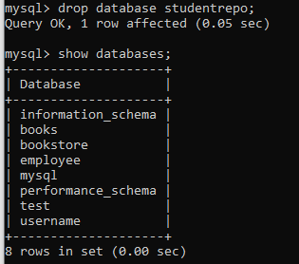

**Restoring the database**

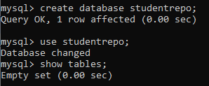

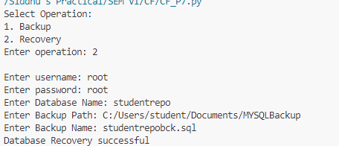

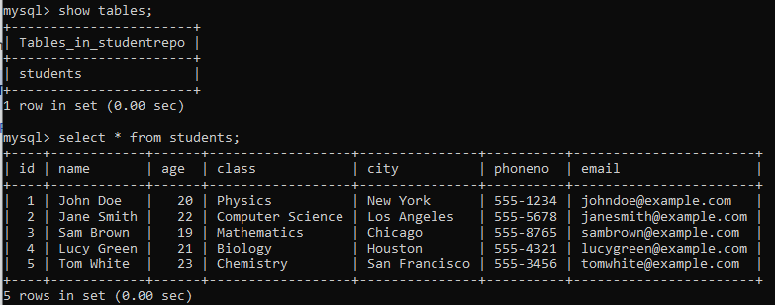

Backup and Restore using DriverImage XML

**Q.1]** Use DriveImage XML tool to do backup and restore on VHD

**Steps:**

1. Install DriverImage XML
2. Open Disk Management
3. Click Action > Create VHD
4. Select Location and size
5. Click Initialize Disk 1 by right click it

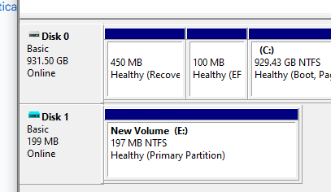

1. Right click unallocated space and Create a simple volume
2. **IMPORTANT: Select MBR as option**

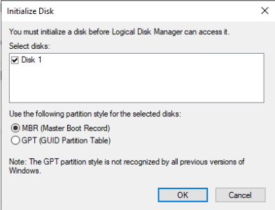

1. Then default steps
2. Create a text file in newly created file

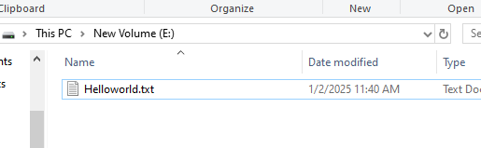

1. Open the software
2. Click backup
3. Choose E drive (or that letter you assigned)

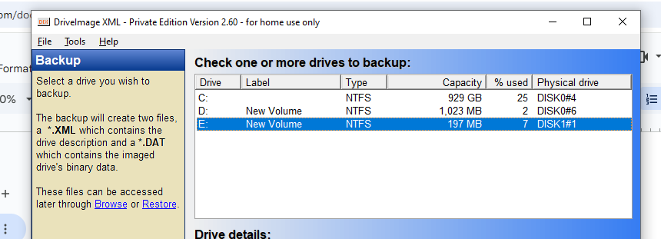

1. Click next

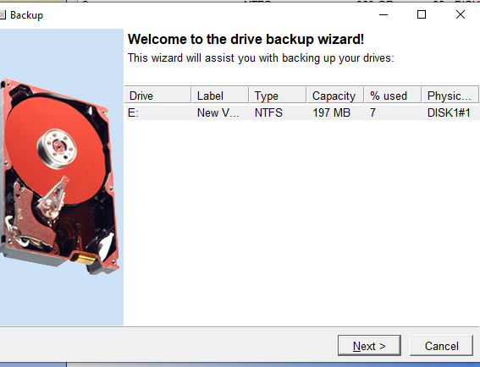

1. Click next

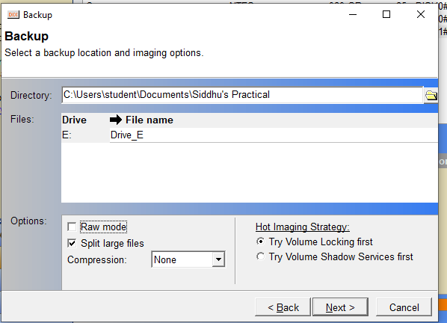

1. Now the delete everything in E Driver
2. Open software, Click restore

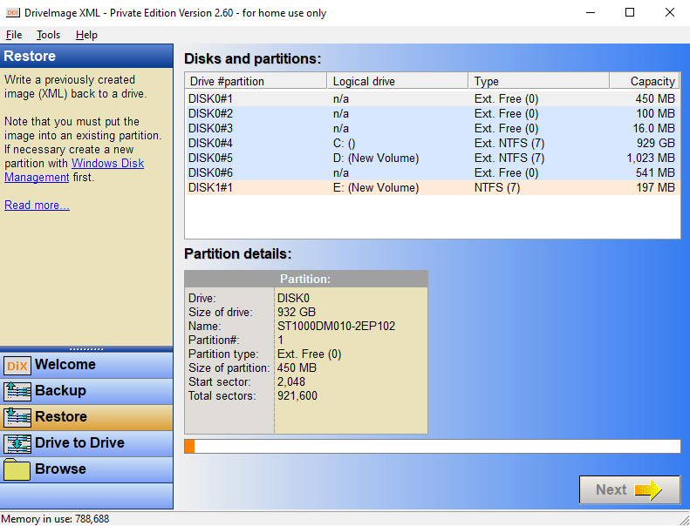

1. Select E Driver
2. Select backup.xml location

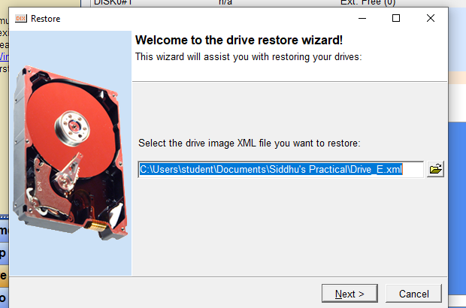

1. Select E Driver

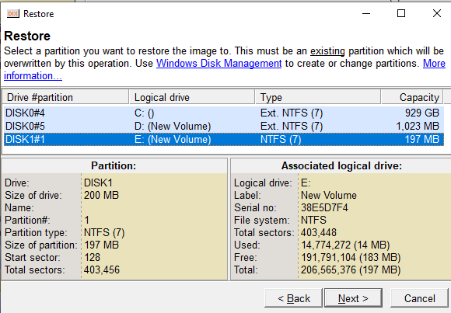

1. Click next

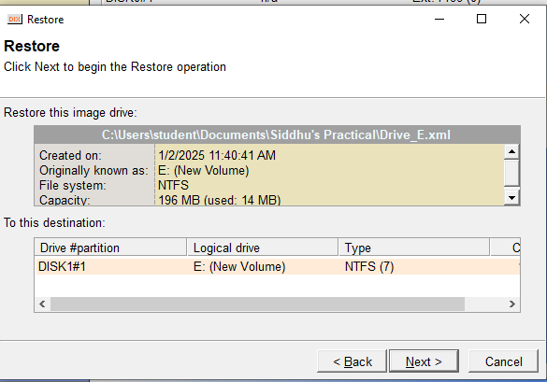

1. Click next and confirm

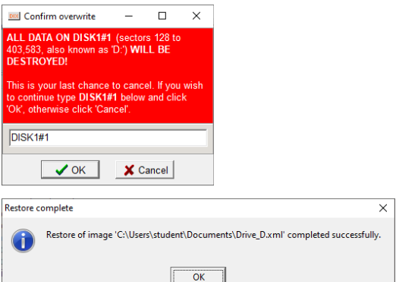

1. Now the drive will be restored

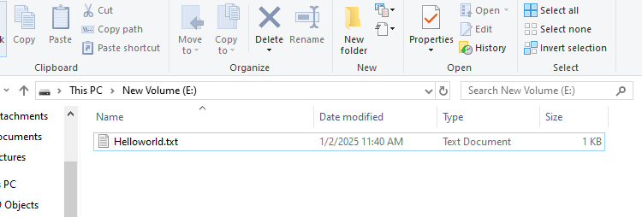

Practical No. 3

Network Forensics

**Aim**- Wireshark

1. **AskSnopes.pcapng**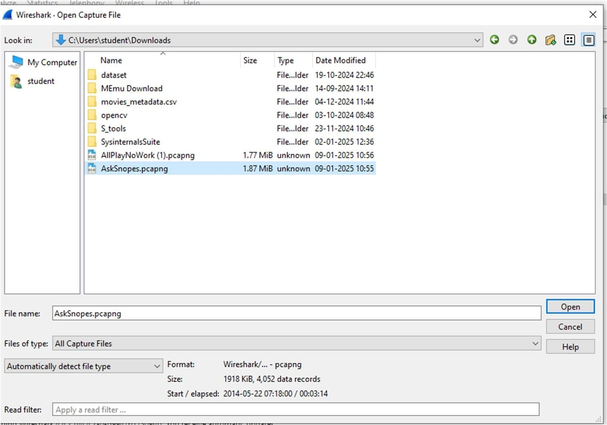

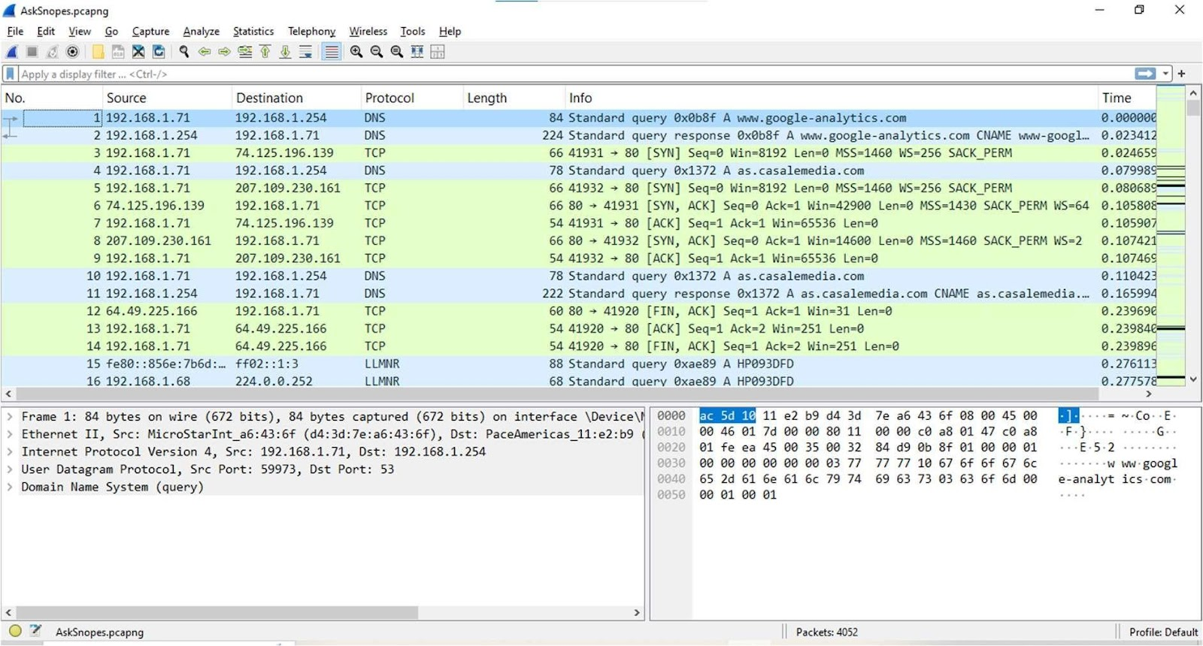

1. What web server software is used by [www.snopes.com?](http://www.snopes.com/)

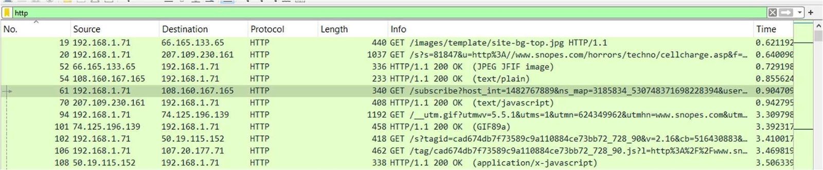

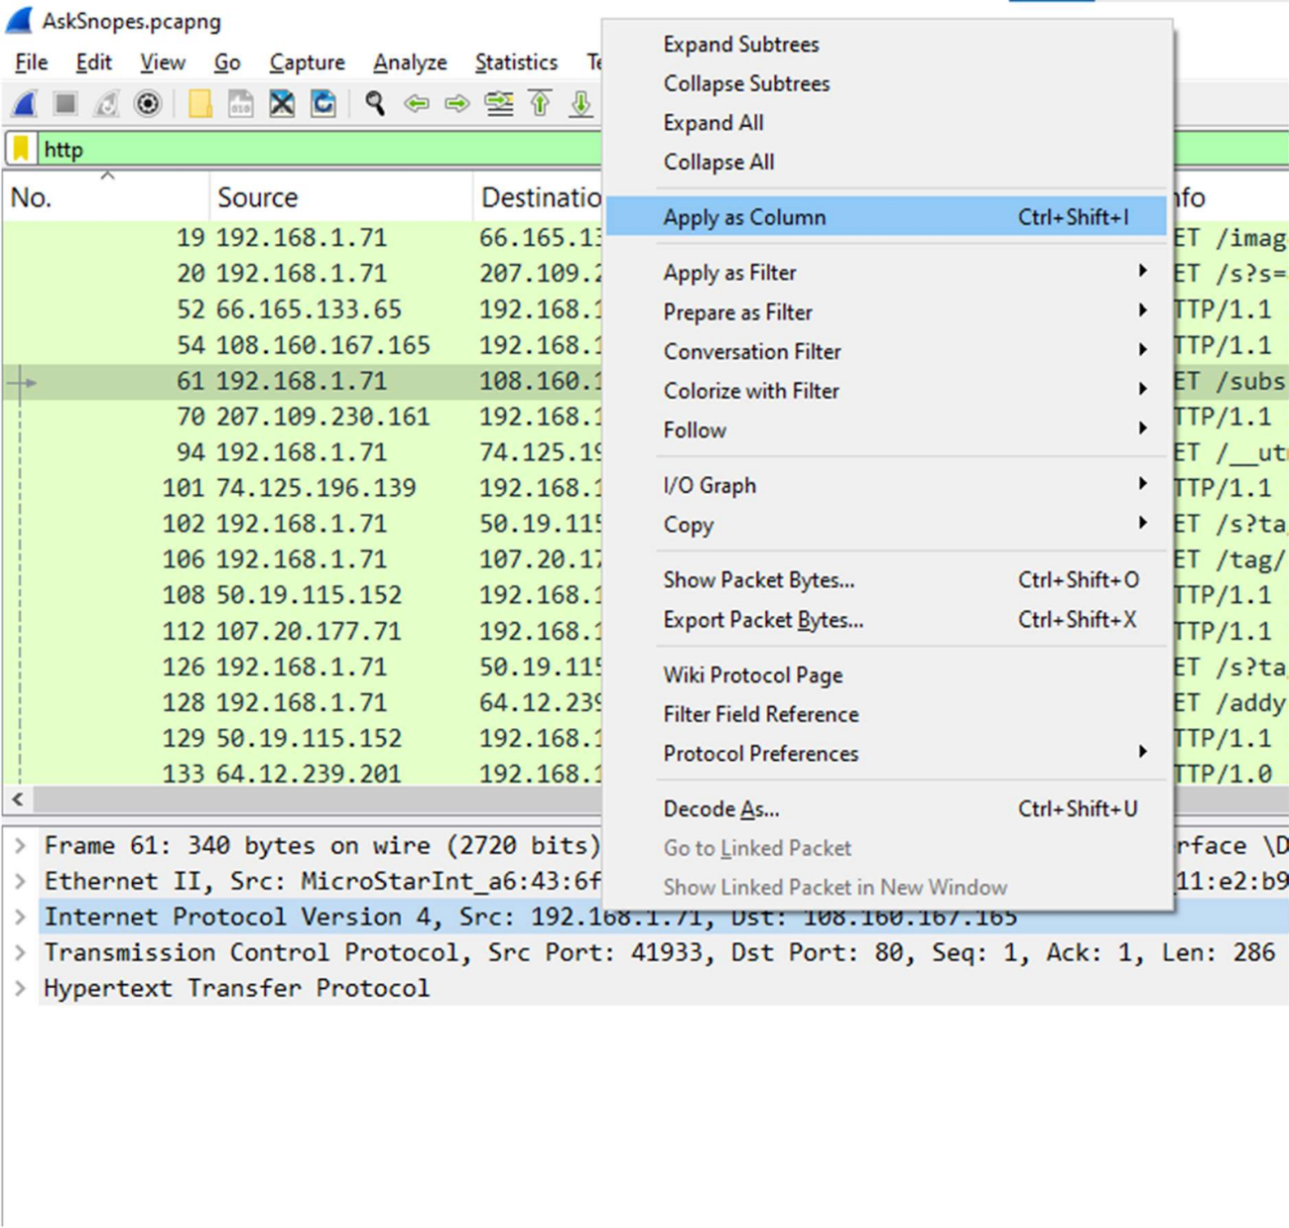

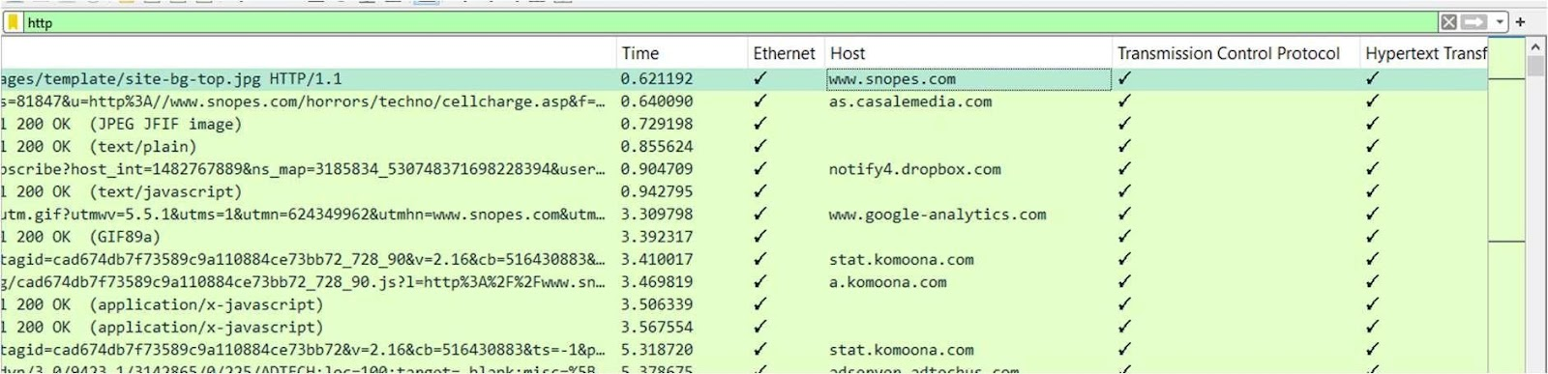

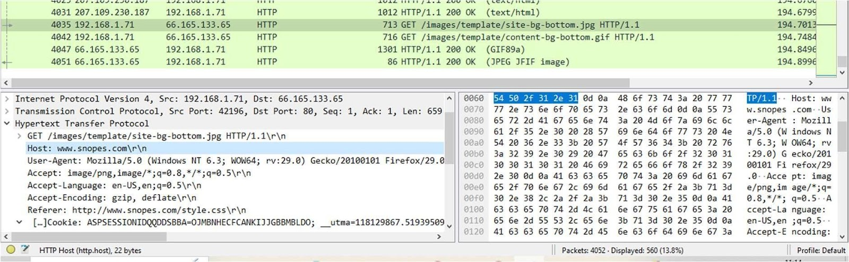

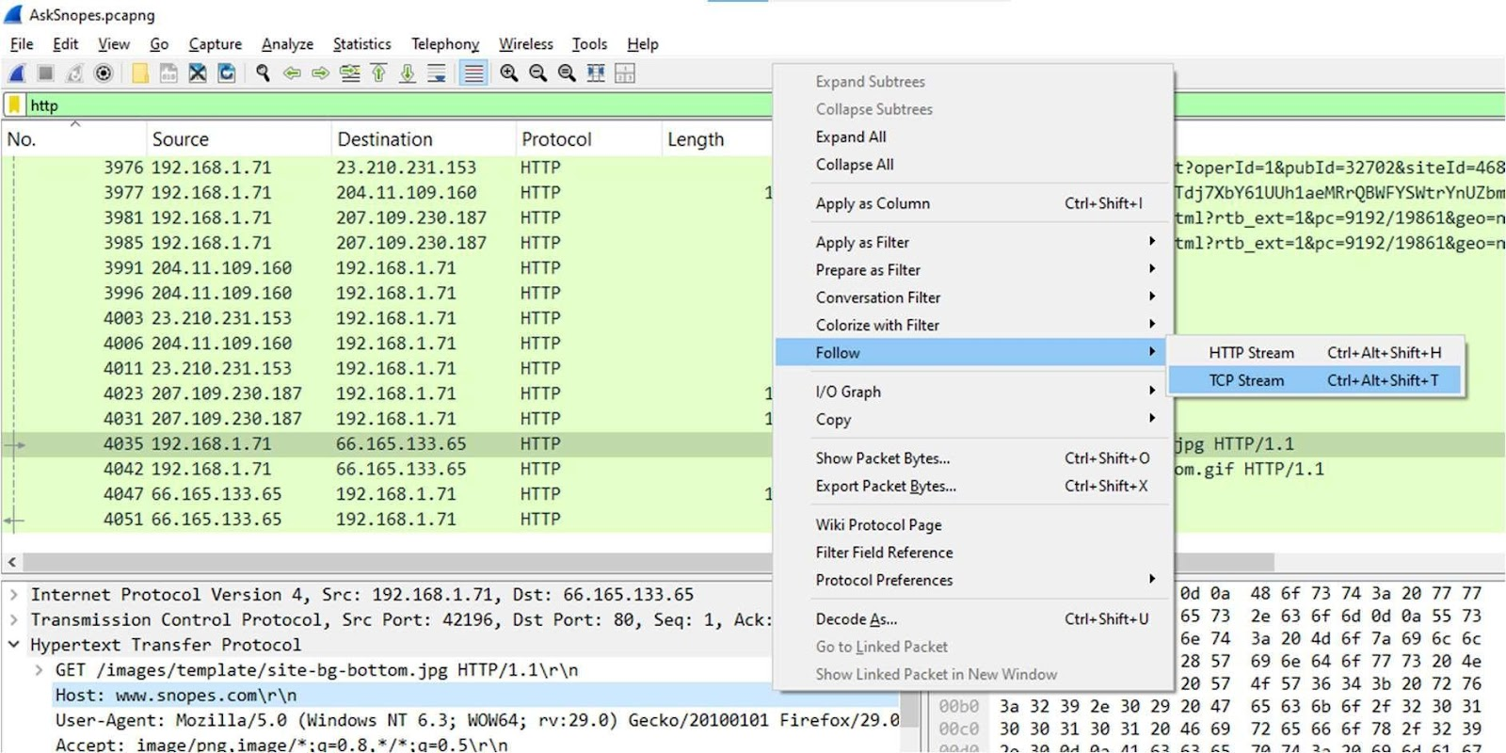

Answer – The web server software used is Microsoft-IIS/5.0

1. About what cell phone problem is the client concerned?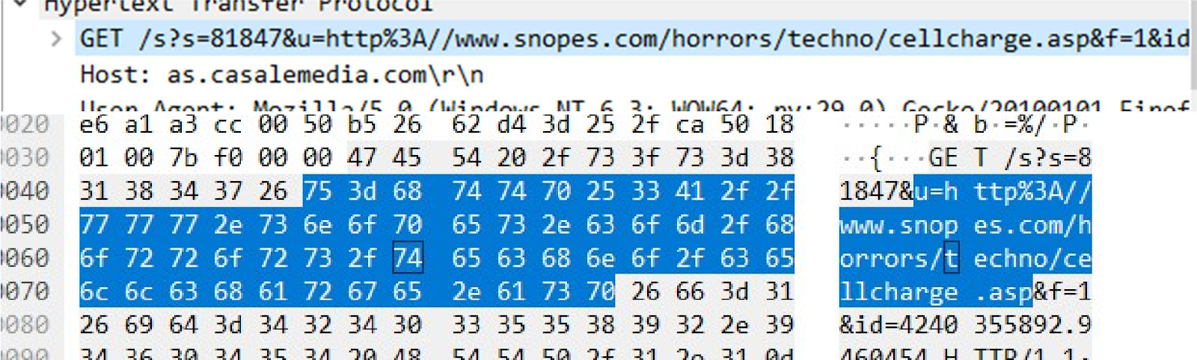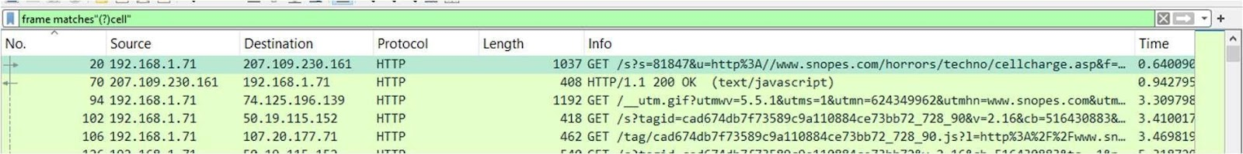

Answer - The user had cellphone charging issue

1. According to Zillow, what instrument will Ryan learn to play?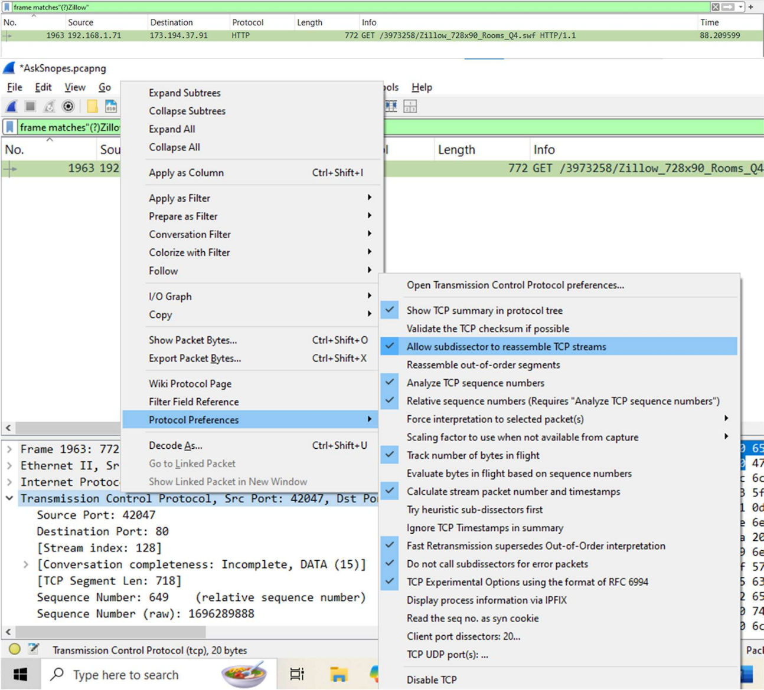

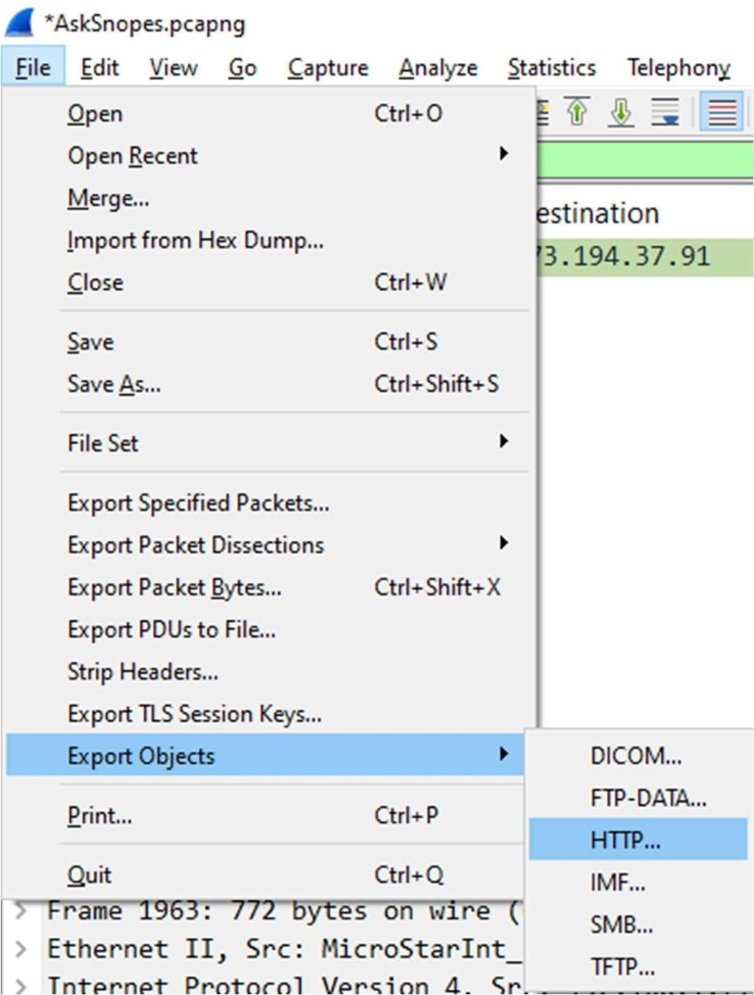

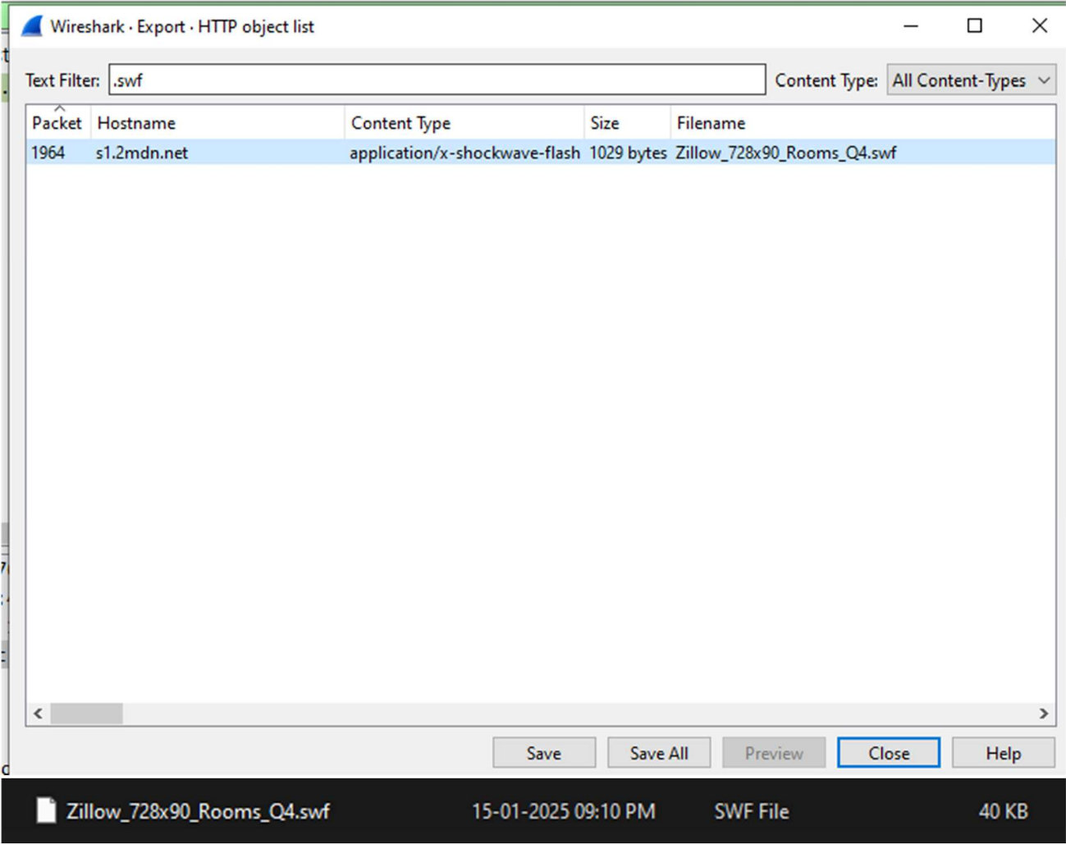

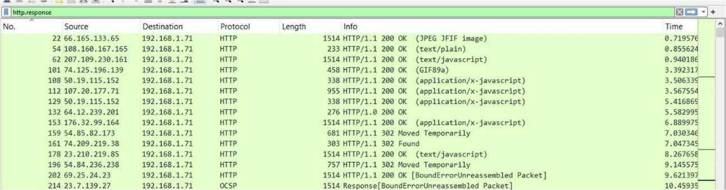

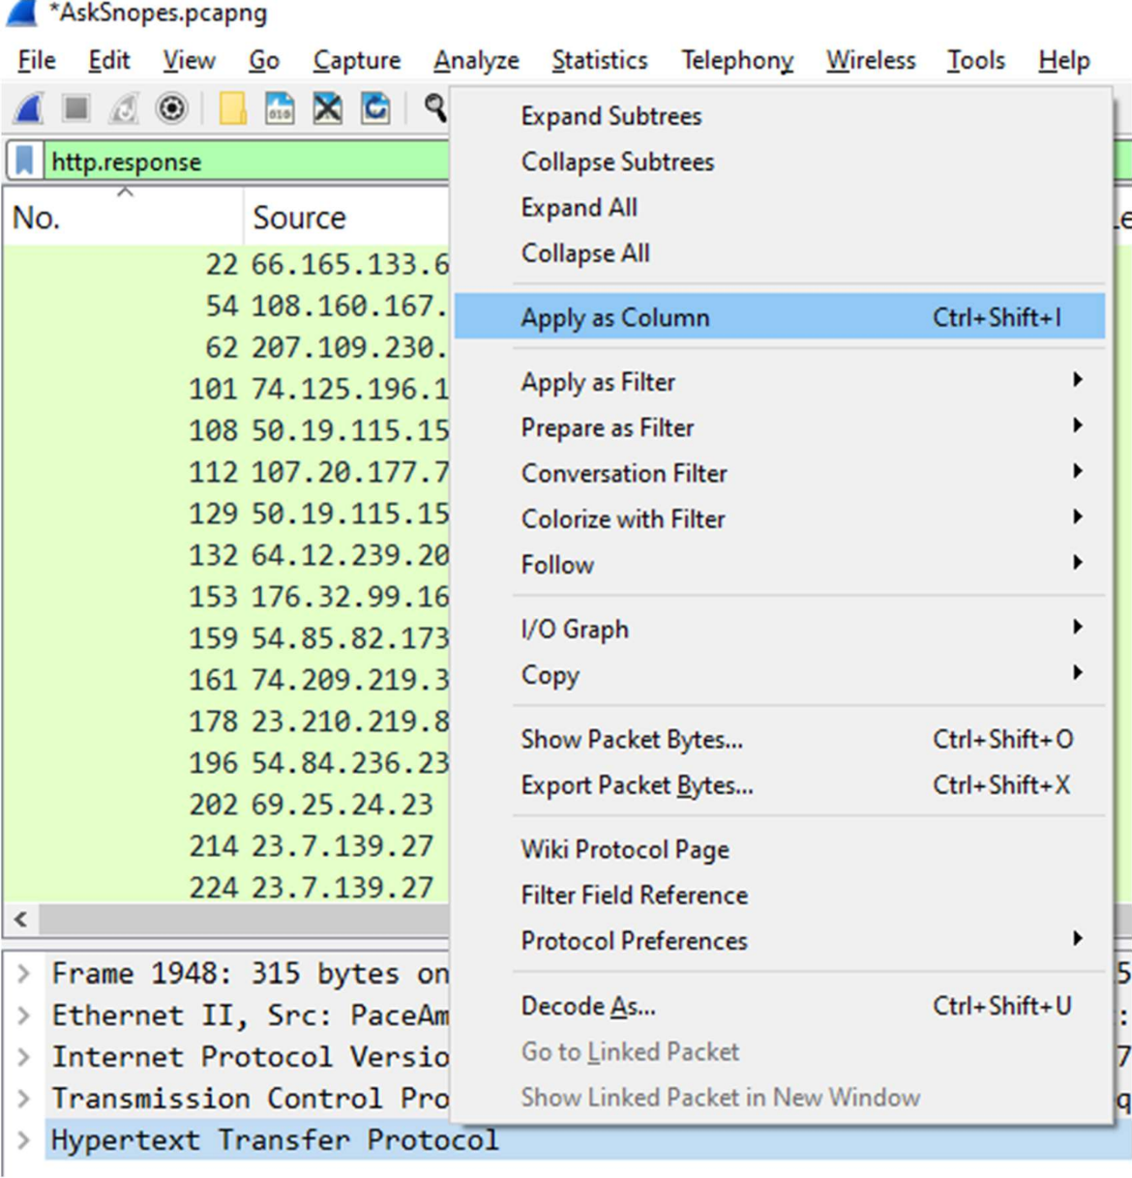

Answer – Ryan will learn saxophone

1. How many web servers are running Apache?

Setfiter as http.response. --> set server header as one of the columns

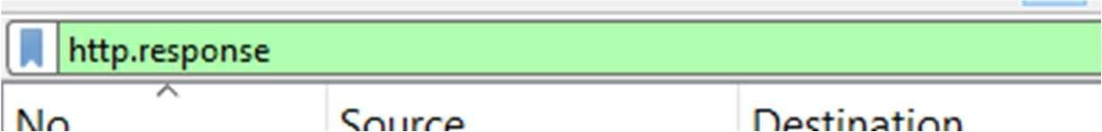

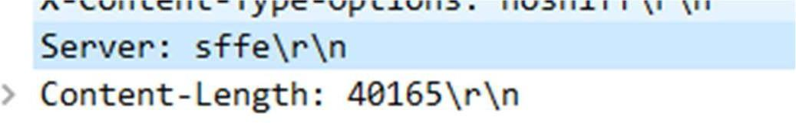

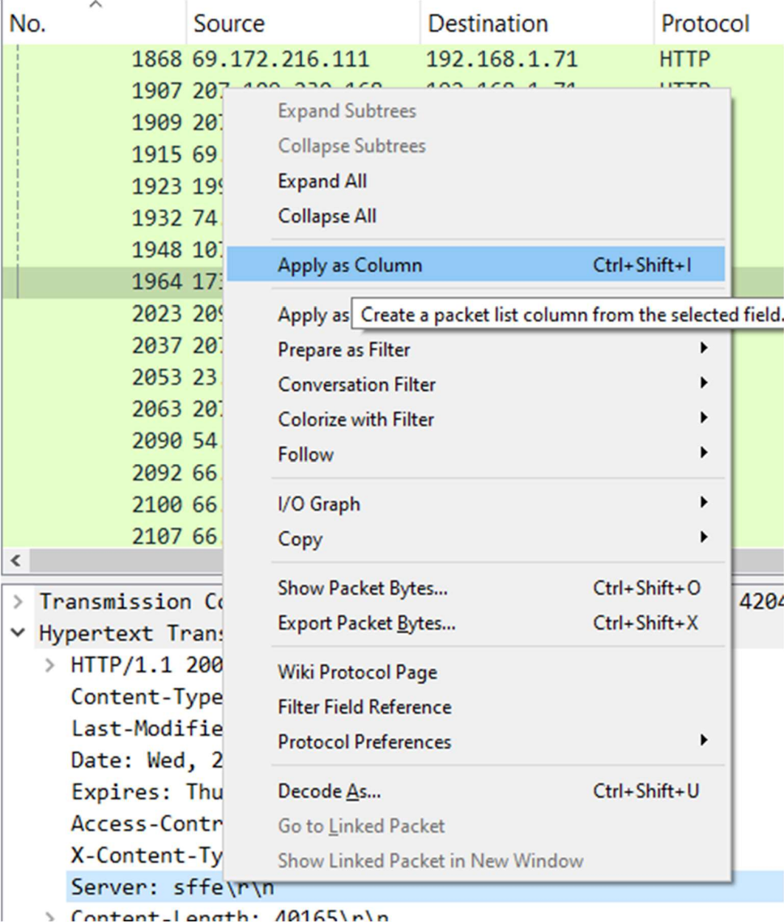

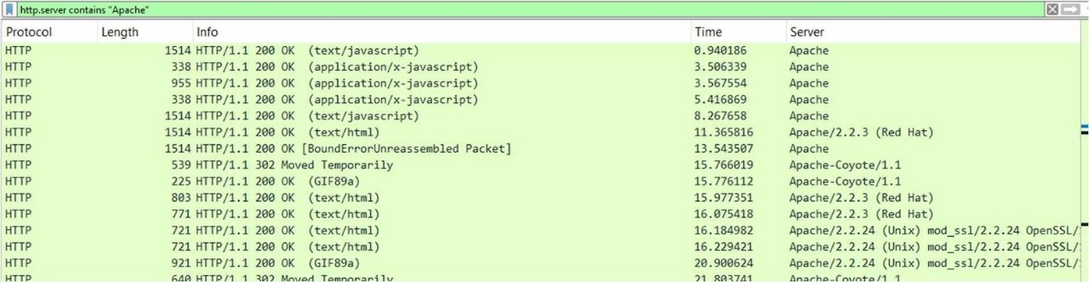

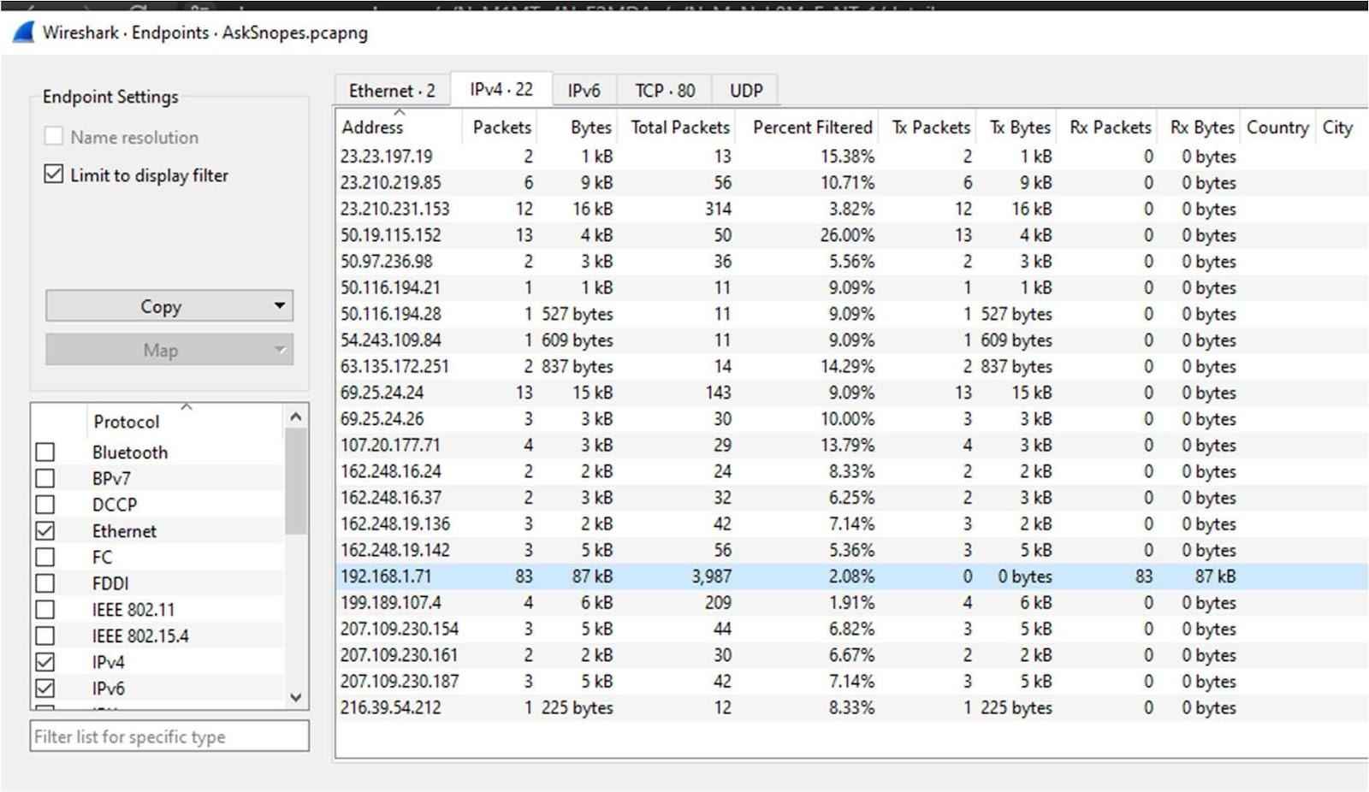

Goto statistics --> endpoints --> tick the “Limit to display filter”

Now there are showing 22 connections but will exclude 192.168.1.71 because it is client’s IP not a server IP so there are actual 21 Apache servers.

1. What hosts (IP addresses) think that jokes are more entertaining when they are explained?

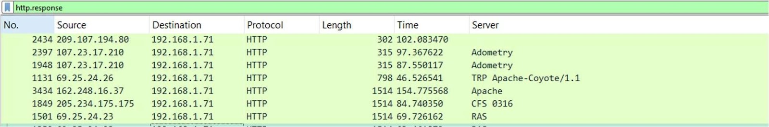

Answer - Hosts that think jokes are better explained:

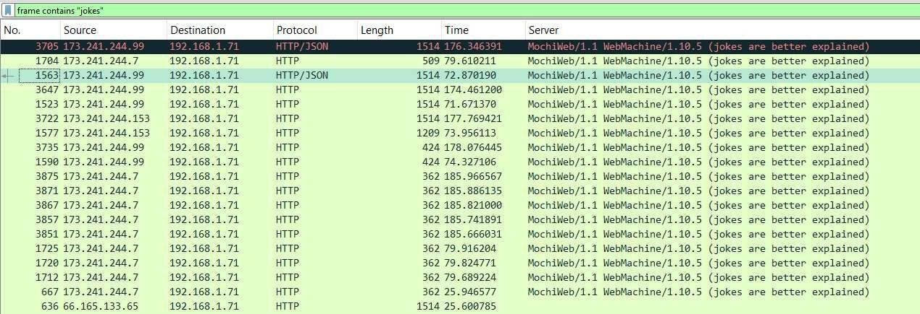

**B. AllPlayNoWork.pcapng**

1. For what server did the client try to resolve an IPv6 address?

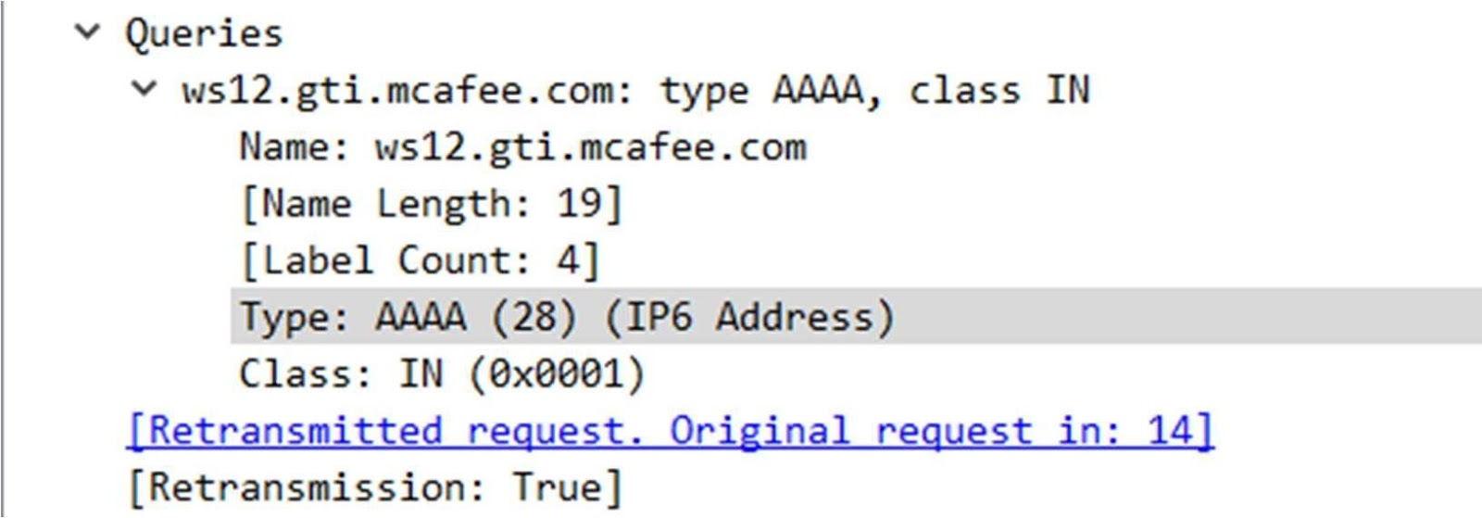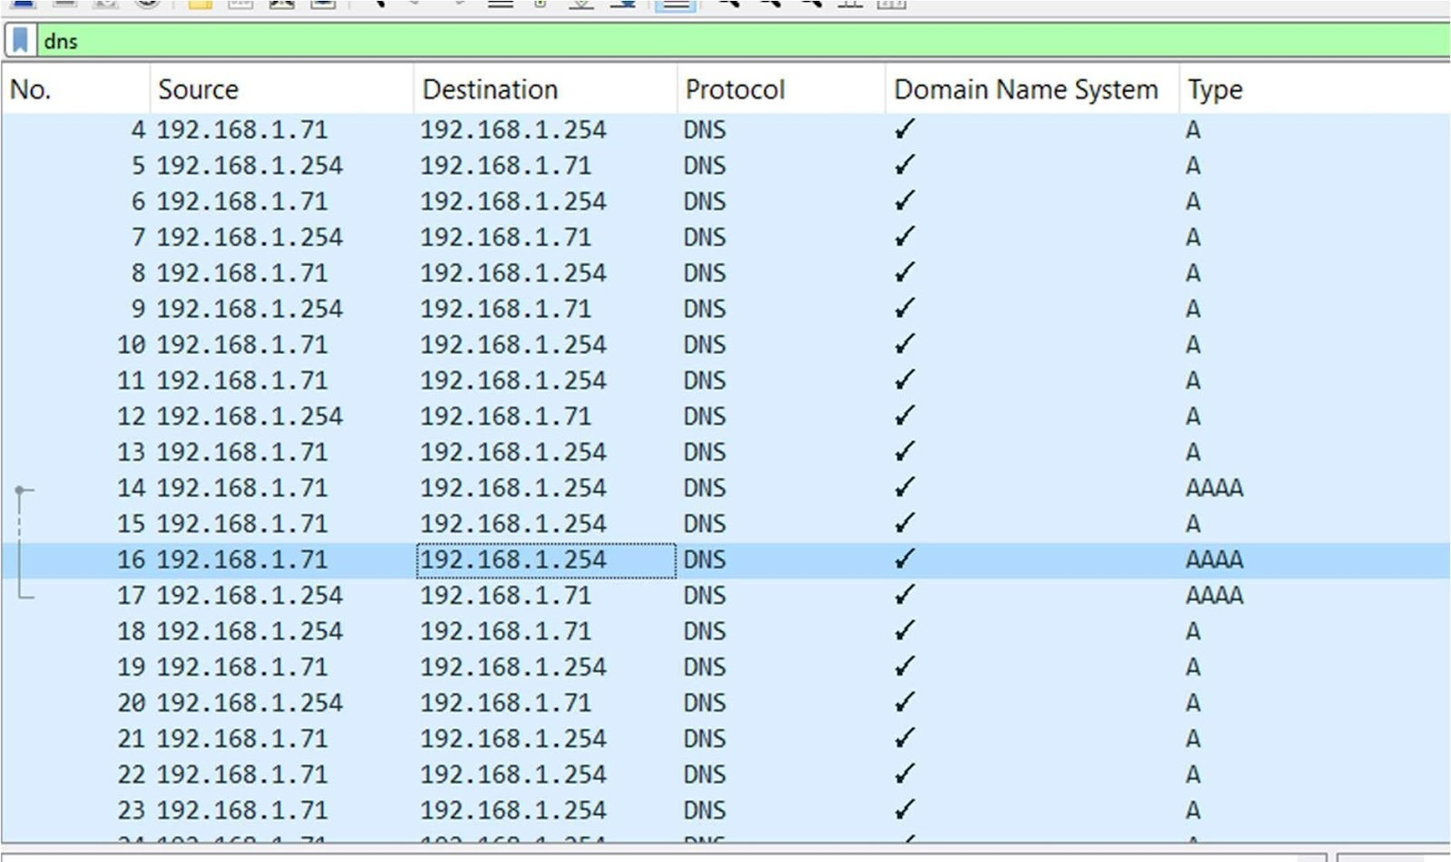

Answer - An IPV6 address resolution looks for the value AAAA in DNS query. We found the DNS query with AAAA value and expanded the query tab where we can see the query is trying to resolve **ws12.gti.mcafee.com**.

1. What operating system do you think the client is running?

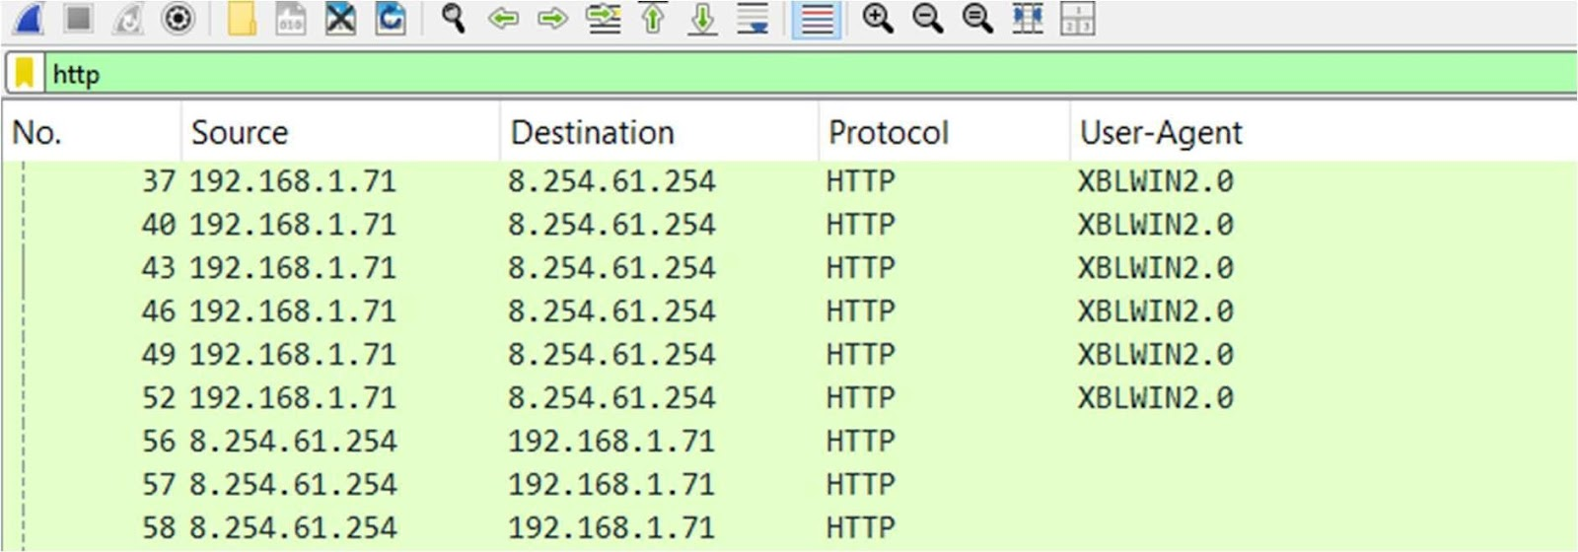

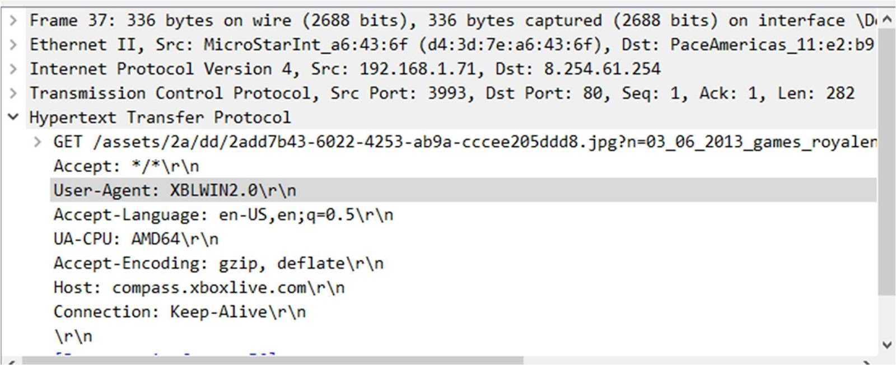

Answer - The client is likely running Windows

1. What is the color of the mermaid’s hair?

File -> Export objects -> HTTP ->filter “mermaid”

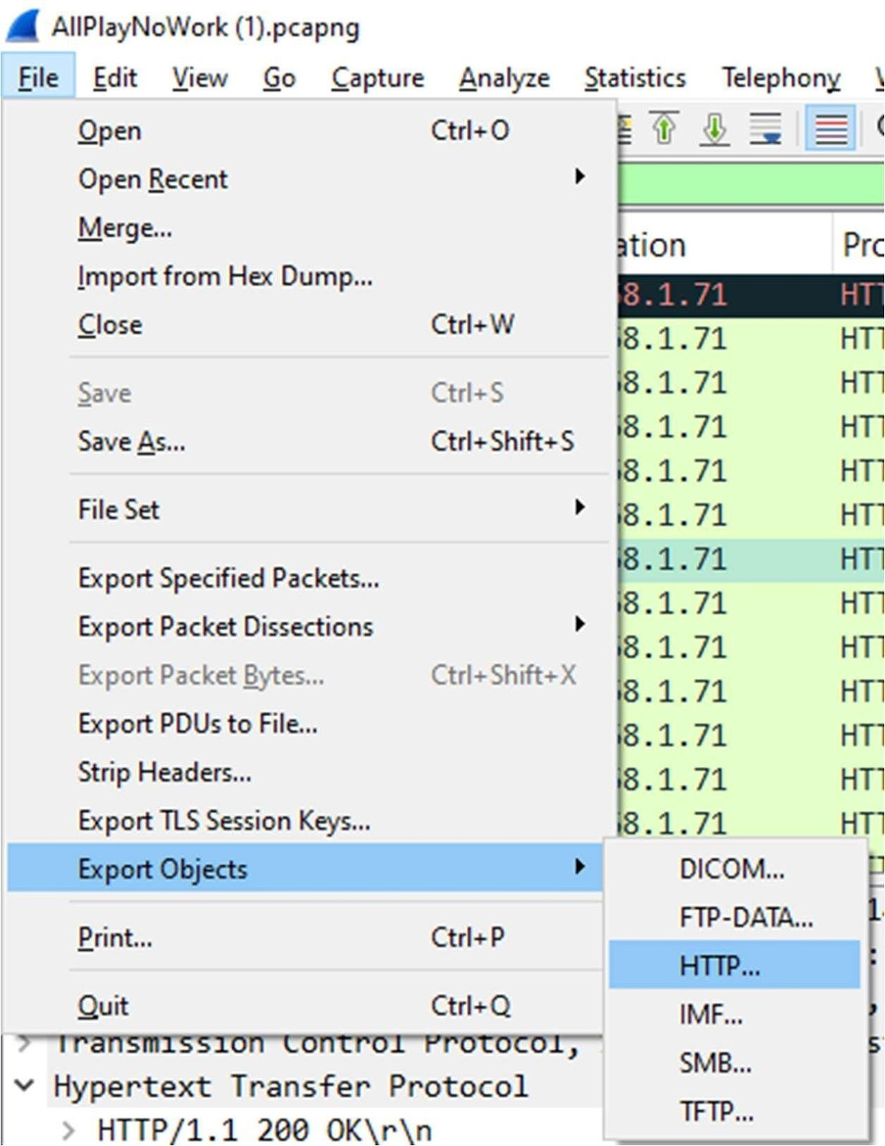

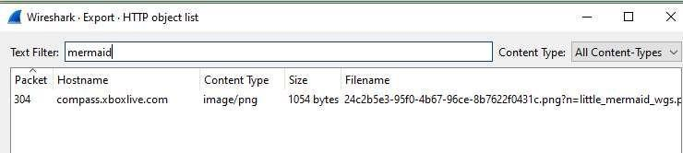

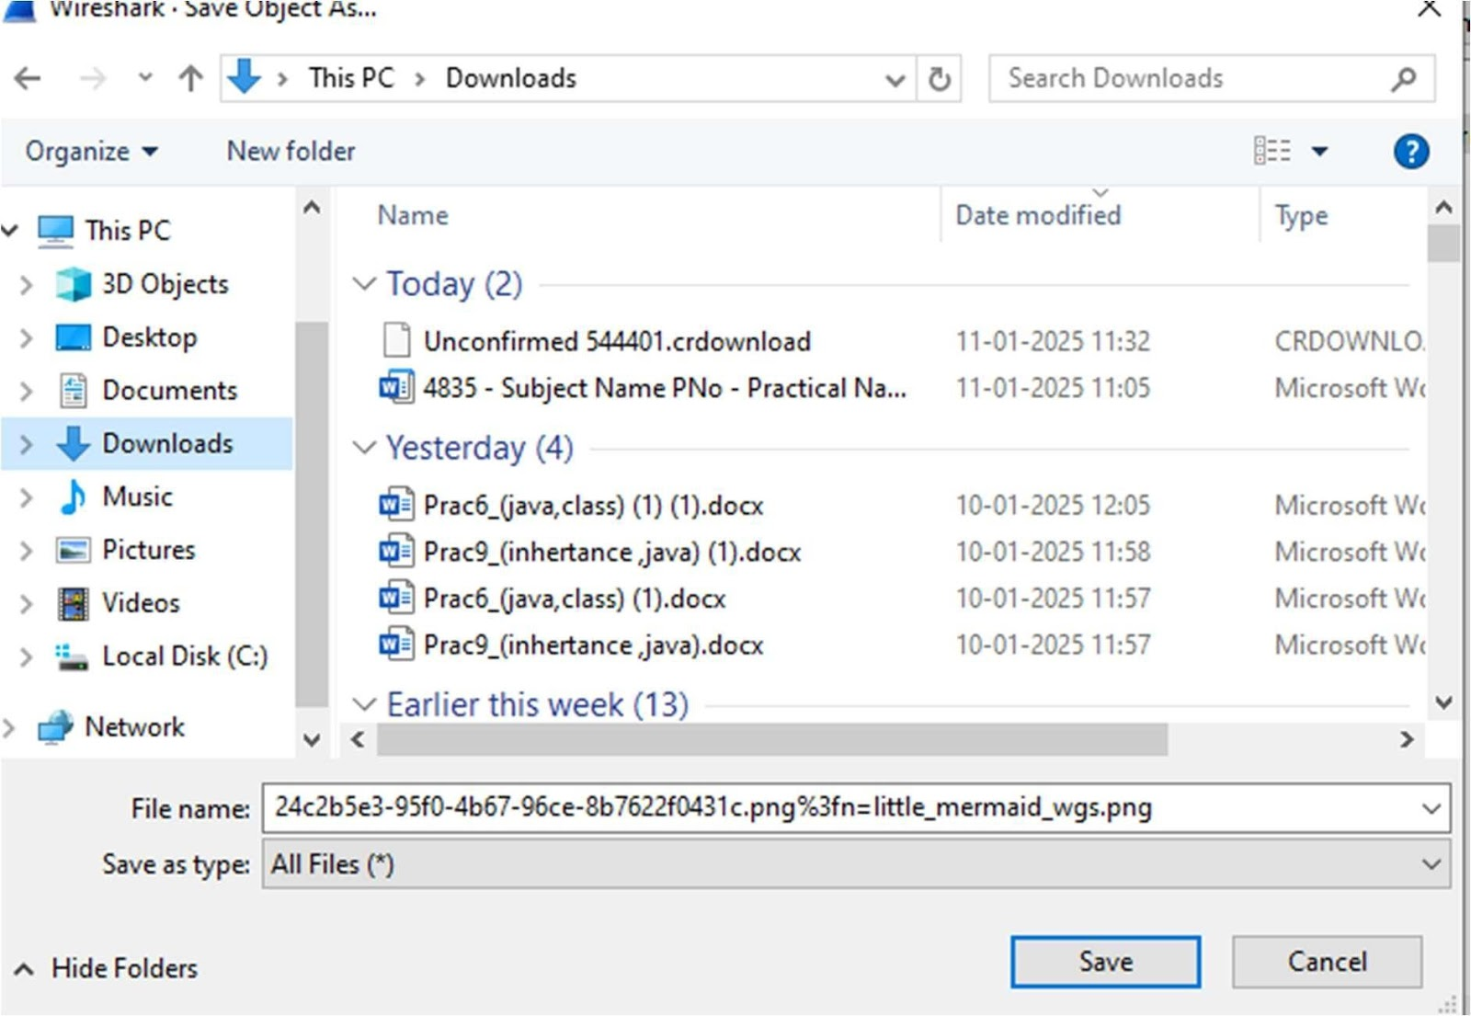



Answer – Hair color of mermaid is red.

1. Find uno and friends.

File --> Export objects --> HTTP --> search “png” -->select the uno and friends image --

> save

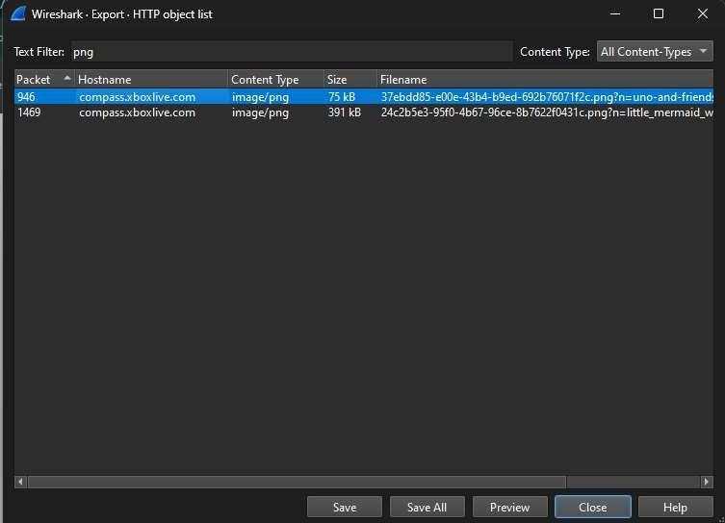



Answer



1. Which Angry Birds edition did the user learn about?

File --> Export object --> Filter “angry” --> save the angry bird image



Answer - It’s angry birds space edition game.